The Biodiversity and Resilience of Ecosystems Report 2025

Name: Carew Community Council
Introduction and Context: Carew Parish Council is a mainly rural area which consists of some 817 households. The centre of the area is Carew village which is also home to Carew Castle, a major Welsh tourist attraction managed by Pembrokeshire Coast National Park Authority. Next to the castle is the tidal mill pond and historic French mill, all connected to the Cleddau Estuary.
The waterway, millpond and Carew castle itself are designated as a Sites of Special Scientific Interest (SSSI) for various species including;
- a nationally scare tidal lagoon worm and
- a transitory roosting and feeding site for greater horseshoe bats and other bat species.
Next door to Carew is the village of Sageston which contains a significant new housing development. There are outlying villages namely Redberth, Milton, Carew Newton, Carew Cheriton, Whitehill and West Williamston. West Williamston is situated next to the Cleddau estuary has a nature reserve managed by the Wildlife Trust of South and West Wales, the reserve is known for its rare butterflies (Brown Hairstreak) and orchids.
The whole area is ecologically connected through the waterway and terrestrially through ribbons of hedgerows, semi natural woodland and larger blocks farmland (mixture of arable, improved/semi-improved grassland).
Part of the parish is in the National Park and the Community Council work closely with our National Park Ranger to promote and enhance biodiversity. The parish is subject to the Wellbeing of Future Generations Act.
Action Report 2023-25
Action carried out to embed diversity into decision making and procurement.
We are concerned with biodiversity in all decisions we make and try to raise awareness of the issue at all our meetings. An example of this is that we arranged a talk about local fauna and flora by a specialist which was open to all residents both in the parish and surrounding area. However we accept that we need to do more and we will look at the issue of procurement. Although we do not procure very much there are areas we could consider e.g Cleaning materials for the Memorial Hall, where we have our meetings, to make sure we minimise the effect on the environment.
In 2025, working with the local National Park Ranger, we have started a Nature Recover Action Plan (NRAP). This plan, for the Carew CC area specifically, will bring together information about our local biodiversity into one document to aid decision making.
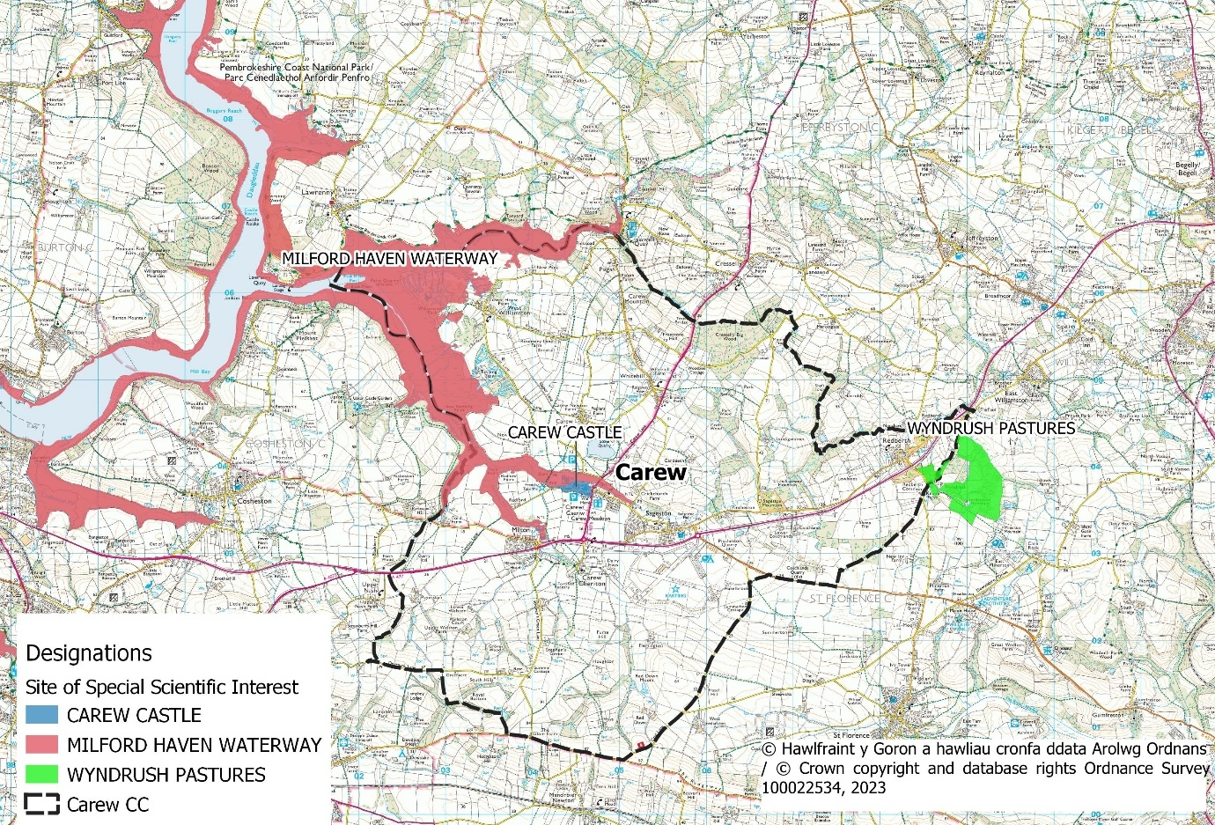
Example of a map produced for the Carew Nature Recovery Action Plan, detailing Sites of Special Scientific Interest in the Carew Parish
Safeguard Principal Species and Habitat
We have important and unique habitats in our area, particularly 3 SSSI and the estuary which are home to many bird species and overwintering birds from other parts of the world. The parish contains many insects and butterflies and regular surveys are conducted by the Wildlife Trust and the National Park. There are also many wild flowers in the area e.g orchids. The National Park has strict criteria for developments in the area and this is also a major concern of the Community Council when considering planning applications. Community Council members have detailed local that knowledge which has enabled us to ensure that planning applications do not impact on Biodiversity.
The Nature Recovery Action Plan will help identify principle habitats and species and will highlight community projects that we could carry out to support them.
Restore and Create Habitats and Resilient Ecological Networks
Although we are working hard to maintain our existing habitats we accept that there is more to do. Last year we set aside a corner of our Milton play area and put in plug plants and let the grass grow longer. Initial results show a more diverse grassland, with flowers such as bird’s foot trefoil, yarrow, wild strawberry and self-heal starting to establish. The area will be cut and raked but less regularly than the play area which should help to control grass growth. We are also considering setting aside other areas to promote wildflower growth namely the sports field and part of the cemetery which we maintain. In addition we are going to install swift boxes in many of our villages.
The National Park has done a great deal to improve biodiversity on the land they are managing, primarily by managing the unimproved grassland as a traditional hay meadow which provide invertebrate food for bats and habitat for numerous small mammals. There have also been improvements to publicly accessible areas (Car parks and picnic sites) by planting trees and hedges. They also maintain the Jubilee Trail near Milton which has many birds and wild flowers.
Tackle Negative Factors eg Reduce Pollution, use Nature based solutions, address invasive species
Our regular litter picks have been very successful with many members of our community taking part. Our National Park Ranger has arranged balsam pulling work parties every year which have included National Park volunteers and local residents. We are now seeing the benefit of this work with the amount of this invasive species declining year on year. All this work is done by hand so as to limit damage done to other plants.
Use, improve and share evidence
As we work closely with the National Park our evidence is shared with them. However we realise we need to do more to share evidence with neighbouring Community and Town Councils to share best practice.
Support Capacity and/or other organisations
We are supporting the National Park in their application for Creswell Quay to become a conservation area, although this is not in our parish, will benefit biodiversity through enhanced tree preservation.
We have given money to the local primary school to buy a polytunnel so that children can grow fruit and vegetables and learn about gardening.
Review of Section 6 duty actions for 2023-2025
What has worked well. Our community litter picks and balsam pulling have worked well. We had a good response from the Community to planting the plug plants in the Milton play area and the local school is making good use of the poly tunnel.
What have barriers been. There have been no specific barriers other than a lack of time and the need to give biodiversity more priority.
What will you change. To give biodiversity more priority we have formed a biodiversity sub committee. We will consider making it a regular monthly item on our agenda.
How and when will the s6 duty be monitored and the plan reviewed. Annually for overall monitoring but specific issues could be raised at each monthly meeting.
Description of Organisation relative to biodiversity.
The Community Council owns the Carew Memorial Hall and car park. Also the War Memorial monument and the Flemish Chimney - both in Carew, and also the Carew Newton Cemetery . We have responsibility for maintaining the 2 play areas of Milton and Carew . As mentioned we are improving the Milton play area and hope to be doing further projects next year. We have planted trees and have planters with flowers round the Memorial Hall.
We would hope that our future NRAP will provide stimulus to encourage other community members to improve how they manage their land for biodiversity, from a small pond to a field.

Agreed and Adopted at Carew Community Council meeting on Wednesday 19th August 2025

Signed: Vice Chair : Marina Griffiths

0-0-0-0-0-0

